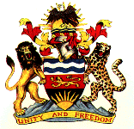

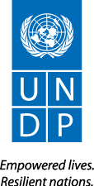

Ministry of Health

Capacity Development in Health Project

(Award No: 72951; Project ID 00085202)

**Progress Report**

January – December 2014

December 2014

**Contents**

Acronyms ………………………………………………………………….… 3

Executive Summary ………………………………………….……………….... 4

1. Situational Background/Context…………………………..……………….…………… 4
2. Assessment of Project Results During the Reporting Period………………. 6

B.1 Progress to Achieving Outputs ……………………….…………… 6

* Output 1: …………………………………………………….…………… 6
* Output 2: …………………………………………………………………. 10
* Output 3: …………………………………………………………………… 12
* Output 4: …………………………………………………………………… 13

B.2 Progress towards Achieving Outcome and Expected Impact …………. 13

B.3 Gender Mainstreaming ……………………………………….…… 15

B.4 Status of Key Partnerships and Inter-Agency Departmental

Collaboration in the Areas of the Outcome ……………………….…... 15

1. Financial Status and Utilization …………………………………… 16
2. Lessons Learned …………………………...………………………. 16
3. Future Work Plan …………………………..………………………. 16

**Tables & Figures & Annexes**

Table 1: Distribution by Area of Specialization ………………….. 6

Table 2: Deployment of Doctors by Specialty/Facility, Jan. – Dec., 2014 7

Table 3: Facilities with Integrated HIV Services in the 5 Zones ….. 9

**Figures**

Figure 1: Top 5 Conditions at KCH …………………………………… 8

Figure 2: Class on Oral Health at Malingunde Primary School …………… 8

Figure 3: Physiotherapy Training by an IUNV at QECH …………… 10

Figure 4: An IUNV Doctor Conducting Pediatric Survey …………… 10

Figure 5: Participants at IUNV Doctor’s Learning Forum …………… 11

Figure 6: Handover of Equipment Sourced by an IUNV Doctor …… 12

Figure 7: Number of Patients Operated on During Outreach Visits …… 14

**Annexes**

Annex I: Project Plan for the Period …………………………………… 17

Annex II: Expenditure by Output …………………………………… 18

**Acronyms**

ART Antiretroviral Therapy

ARVs Antiretroviral

AWP Annual Work Plan

CDIs Capacity Development Initiatives

CEZ Central East Zone

CHAM Christian Health Association in Malawi

COM College of Medicine

COSECSA College of Surgeons East, Central and Southern Africa

CPD Continuous Professional Development

CWZ Central West Zone

DEAP Development Effectiveness and Accountability Program

EHP Essential Health Package

GFATM Global Fund for the Fight against AIDS, Tuberculosis and Malaria

GoM Government of Malawi

GPs General Practitioners

HIV/AIDS Human Immunodeficiency Virus/Acquired Immunodeficiency

HSSP Health Sector Strategic Plan

IUNV International United Nations Volunteer

JOVC Japanese Overseas Volunteer Cooperation

KCH Kamuzu Central Hospital

MCH Mzuzu Central Hospital

MCM Medical Council of Malawi

MoH Ministry of Health

NAC National AIDS Commission

QECH Queen Elizabeth Central Hospital

RCC Rolling Continuation Grant

RNE Royal Norwegian Embassy

SMD Society of Medical Doctors

SEZ South East Zone

SPs Specialists

SWZ South West Zone

UNAIDS Joint United Nations Program on HIV/AIDS

UNDP United Nations Development Program

UNICEF United Nations Children’s Fund

WHO World Health Organization

ZCH Zomba Central Hospital

**Executive Summary**

Overall, the Capacity Development in Health Project met most of its objectives during the January to December 2014 reporting period. Key to the success of the Project was the retention and recruitment of International United Nations Volunteer (IUNV) doctors almost reaching the agreed target of 44 in 2014. This followed satisfactory funding situation. A total of $2,605,108 was mobilized -- $1,675,978 from the Royal Norwegian Embassy (RNE) and an additional $929,129[1] from the Global Fund to fight Against Tuberculosis, AIDS and Malaria (GFTAM) through the National AIDS Commission (NAC) .

The highest number of doctors recruited and deployed during the year stood at 42, slightly falling short of the 44 target. The target would have been met had it not that some doctors resigned -- making it somewhat difficult to reach the targeted number. These doctors were largely deployed in the four central hospitals – Mzuzu, Lilongwe, Zomba and Queen Elizabeth and district hospital zonal offices where they continued to render valuable services. Their contribution was well captured by the Hospital Director for Zomba Central Hospital who stated that quote *“If they were to leave, we would cease to be a referral hospital”*.

Significant quantities of equipment were procured in 2014 under the Capacity Development Initiatives (CDIs). This equipment was necessary to facilitate the work of IUNV doctors considering acute shortages in almost all of the country’s hospitals. A total of $200,000 was used to procure equipment which included an autoclave and other basic medical equipment. The doctors were also involved in soliciting equipment from friends and organizations in their home countries. In terms of service delivery, IUNV doctors continued to provide healthcare services to the Malawian citizenry including bedside and lecture training for junior doctors. These trainings included physiotherapy, surgery, anesthesia, medicine and obstetrics and gynecology.

Another notable achievement during the reporting period was preparation of an *“UNV Doctors Exit/Retention Strategy”* to inform subsequent steps to phasing out of the Project and also provide the basis for mobilization of funds. The Strategy concluded that the Ministry of Health will need between 35-43 IUNV doctors, especially specialist doctors, for the next five years, up and including 2019 at an estimated total of $13 million.

There were a number of implementation challenges during the reporting period. Following the Strategy, focus was on mobilizing the $3 million bridging funding for the Project to cover 2015. Unfortunately, both the Ministry of Health and UNDP were unable to mobilize these funds. As a result, a decision was made during the September 2014 Extraordinary Meeting that contracts for all IUNVs should only run up to their expiry dates. As a result, 25 doctors were repatriated by December 31, 2014 following the expiry of their contracts. An additional 4 terminated their contracts prematurely either on personal grounds or uncertainties about funding -- with only 10 IUNV doctors remaining in 2015[2].

Furthermore, procurement of equipment took longer than expected. By December 31, 2014, some equipment had not yet arrived. This compromised delivery of healthcare services. Administratively, the hospitals could not provide counterparts at appropriate levels to ensure skills and knowledge transfer. This was further complicated by difficulties by some IUNV doctors to properly integrate within the hospital administration.

1. **Situational Background/Context**

The Capacity Development in Health Project has been under implementation since 2004. It started as an integral part of a 6-year national Emergency Human Resources Program in the Health Sector. In 2004, under the Southern Africa Capacity Initiative (SACI) Project,nine (9) international medical specialists were recruited to fill crucial gaps in the health service sector. In 2005, the Project grew as the Ministry of Health made available funds from GFTAM to recruit more medical doctors and antiretroviral therapy (ART) supervisors for central and district hospitals. These funds were disbursed to the Government of Malawi (GoM) through Ministry of Health’s Health Systems Strengthening (HSS) Grant and NAC through Rolling Continuation Grant (RCC) Grant. In 2014, RNE provided a one-off cost sharing contribution to assist the Project recruit and retain the target number of 44.

The Project’s overall goal is to strengthen the capacity of the Ministry of Health to deliver quality health services in Malawi. Specifically, the Project is focused on the recruitment and placement of IUNVs doctors as medical specialists (SPs) and general practitioners (GPs) to work in Malawian central and district hospitals while the Ministry increases its own stock of local doctors. This is being achieved through the implementation of following outputs:

* **Output 1:** UNV doctors have increased coverage of the expanded Essential Health Package (EHP) interventions in Central, District and Christian Health Association of Malawi (CHAM) hospitals by 2016**.**
* **Output 2**: The College of Medicine (COM), Kamuzu Central Hospital (KCH) and Queen Elizabeth Central Hospital (QECH) are able to deliver specialist training to strengthen the performance of the Health System in anesthesia, physiotherapy and surgery by 2016.
* **Output 3:** Three central hospitals establish specialized units for physiotherapy, cardiology and oncology disease conditions by 2016.
* **Output 4:** Effective and efficient project management.

The Project outputs are well aligned to the Malawi Growth and Development Strategy (MGDS) II, Theme **2** (Social Development), Sub-Theme 2 (Health); Theme **6** (Gender and Capacity Development), Sub-Theme 2 (Capacity Development) and Priority Area No. 5**:** (Public Health, Sanitation, Malaria and HIV&AIDS management). It also supports the EHP as outlined in the Ministry’s 2011-2016 Health Sector Strategic Plan (HSSP). The Project contributes to Outcome 4.2 *“Public institutions are better able to manage, allocate and utilize resources for effective development and service delivery by 2016”,* and *“Output 4.2.1: Capacity for public sector management strengthened for effective service delivery”* of the 2012-2016 United Nations Development Assistance Framework Action Plan (UNDAF-AP).

Strategic areas of the Project include: recruitment and deployment of GPs and SPs to district and central hospitals in line with Ministry’s policy to promote the development of local junior doctors; providing support to the COM training of GPs and in-service training for junior doctors and other medical personnel; training of junior Malawian doctors in key areas which need urgent support such as physiotherapy, anaesthesiology; provision of basic medical equipment for effective performance of IUNV doctors; establishment of specialised units; and scaling up of ART services throughout the country through deployment of ART Supervisors in regional health zones.

The Project is being implemented through the Ministry of Health with IUNV Unit and UNDP as the responsible parties. Other partners include NAC, Medical Council of Malawi (MCM), COM, World Health Organization (WHO), REN, HIV/AIDS and Joint United Nations Program (UNAIDS).

1. **Assessment of Project Results During the Reporting Period**

**B.1 Progress to Achieving Outputs**

***Output 1*:** *Central, district and CHAM hospitals have increased coverage of the expanded Essential Health Package interventions in Central, District and CHAM hospitals by 2016****.***

* ***Indicator 1:*** *% of patients accessing essential healthcare package services provided by UNV specialist doctors.* ***Baseline:*** *TBD;* ***Target:*** *30% increase from baseline by 2016.*
* ***Indicator 2:*** *# of COM graduates interning as junior resident medical officers with support of UNV specialist per annum. Baseline: 30 (2012); Target 50 (2014).*

Although there was no survey done to set baseline for percentage of patients accessing healthcare package services provided by IUNV specialist doctors to determine progress made against Indicator 1. Anecdotal evidence shows that there was significant achievement towards this indicator. The mere fact that 42 of the 44 were recruited and/or retained during the period meant that most of the healthcare services were rendered. Tables 1 below provides breakdown of areas of specialties of IUNV doctors and deployment by facility.

**Table 1:** Distribution by Areas of Specialization

|  |  |  |  |
| --- | --- | --- | --- |
| **Cadre** |  | **Number** | **%** |
| Dentists | *GPs* | *5* | ***16*** *12.2%****.66%*** |
| General Practitioner | *GPs* | *7* | *17.1%* |
| General Surgeons | *SPs* | *6* | *14.6%* |
| Physiotherapists | *SPs* | *3* | *7.3%* |
| Pediatrician | *SPs* | *4* | *9.8%* |
| Orthopedic Surgeon | *SPs* | *2* | *4.9%* |
| Ophthalmologist | *SPs* | *2* | *4.9%* |
| Obstetricians/Gynecologists | *SPs* | *3* | *7.3%* |
| Anesthesiologists | *SPs* | *1* | *2.4%* |
| Trauma & Emergency specialists | *SPs* | *1* | *2.4%* |
| Medical Specialist | *SPs* | *2* | *4.9%* |
| Pathologist | *SPs* | *1* | *2.4%* |
| ART Supervisors – (HIV/AIDS) | *GPs* | *4* | *9.8%* |
| **Total** |  | ***41*** | ***100.0%*** |

In line with the policy of the Ministry of Health, there was a shift in the recruitment from GPs to SPs. Of the 41 doctors, 59% were SPs and 41% were GPs. In terms of location, 90.2% of IUNV doctors and other cadres of health workers were based in the three central hospitals. (See Table 2 below). The distribution was (34%) at Kamuzu Central Hospital, 19.5% at Queen Elizabeth Central Hospital with the same percentage for Zomba Central Hospital and 14.6% for Mzuzu Central Hospital. A total of 9.8% were ART Supervisors deployed one each in the South Eastern and South Western Zones (in the Southern Region), Central and Central West Zones (in the Central Region) and Northern Region.

**Table 2:** Deployment of Doctor by Specialty and by Facility, January – December 2014

|  |  |  |  |  |  |  |
| --- | --- | --- | --- | --- | --- | --- |
| **Cadre** | **KCH** | **MCH** | **QECH** | **ZCH** | **ART Supervisors[3]** | **Total** |
| General Surgeons | 1 | 1 | 1 | 1 | - | 4 |
| Pediatricians | 1 | 1 | 3 | 1 | - | 6 |
| Neurosurgeon | 1 | - | - | - | - | 1 |
| Anesthesiologist | - | - | 1 | - | - | 1 |
| Internal Medicine | 1 | - | 1 | - | - | 2 |
| Obs. & Gyn. | - | 1 | - | 2 | - | 3 |
| Orth. Surgeons | 1 | 1 | - | - | - | 2 |
| Ophthalmologists | 2 | - | - | - | - | 2 |
| Pathologists | 1 | - | - | - | - | 1 |
| Physiotherapists | 2 | - | 1 | - | - | 3 |
| Dentists | 3 | 1 | - | 1 | - | 5 |
| GPs | 1 | 1 | 1 | 3 | - | 7 |
| ART Supervisors | - | - | - | - | 5 | 4 |
| **Total** | **14** | **6** | **8** | **8** | **5** | **41** |

These doctors provided a number healthcare services ranging from surgery, dental, physiotherapy, ART supervisory as well as outreach activities. For example, the arrival of an IUNV specialist doctor at QECH became the second paediatric surgeon in Malawi serving a population of about 7 million children. Paediatric surgery is unique as operation is done on all body parts unlike other specialities where it is defined by an area of the body. Figure 1 below shows an IUNV doctor conducting surgery on a child.

Another service that was provided extensively during the year 2014 was oral health care. Research has shown that oral health is one of the most neglected areas of global health and yet 90% of the people have had dental problems. Statistics showed that of the 14,387 patients seen at KCH, the top 5 dental conditions included toothache, fracture, soft tissue trauma, dental abscess and periodontal disease (see Figure 1).

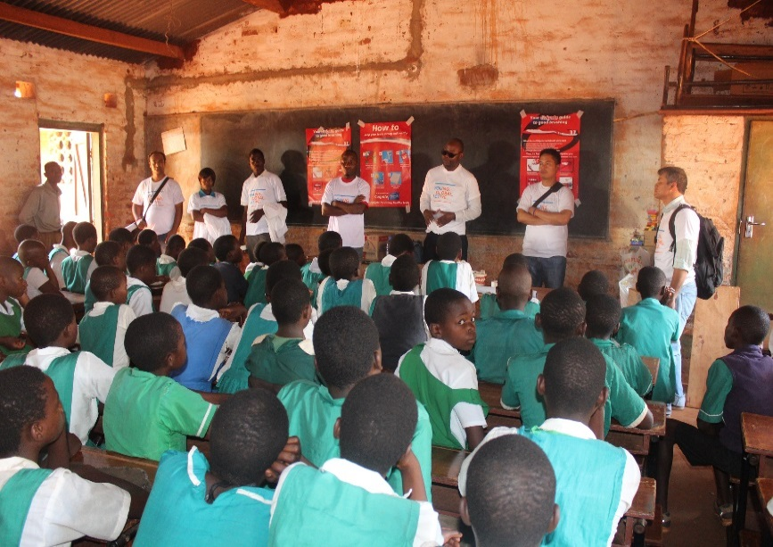Conducting an Oral Health Survey around the City of Lilongwe in 2014, it was discovered that a girl in Areas 25, approximately 10 kilometers from KCH, had never used toothbrush or toothpaste in her life. If this condition was left unattended, it would have developed into a gum disease or even oral cancer. Realizing this, an IUNV dentist and his colleagues from KCH started outreach activities teaching primary school pupils on taking care of their teeth. Figure 2 shows a class on oral health in session at Malingunde Primary School – one of the rural area schools in Lilongwe District.

Figure 2: Class on Oral Health at Malingunde Primary School

IUNV ART Supervisors continued their out outreach activities in district hospitals and assist in skills transfer to clinical officers on how to handle different cases. Table 4 shows availability of ART services in the 5 zones – Northern Zone, Central East Zone, Central West Zone, South West Zone and South East Zone. A total of 34,905 was reached out in the first half of 2014 compared to 28,845 for the whole year in 2013.

|  |  |  |  |  |  |  |  |  |  |  |  |  |  |  |
| --- | --- | --- | --- | --- | --- | --- | --- | --- | --- | --- | --- | --- | --- | --- |
| **Table 3: Facilities with integrated HIV services in the 5 Zones. Availability of Services**  **Defined by Performance** | | | | | | | | | | | | | | |
| Zone | Total fac. (1) | Facilities providing HIV Services | | | | | | | | CD4 count machines (2) | | | | Results |
| Exp. Child | | Pre-ART | | PMTCT B+ | | ART | | Installed | | Functional | |
| NZ | 128 | 113 | 88% | 116 | 91% | 104 | 81% | 118 | 92% | 27 | 21% | 26 | 96% | 2,663 |
| CEZ | 96 | 89 | 93% | 89 | 93% | 81 | 84% | 94 | 98% | 17 | 18% | 16 | 94% | 3,019 |
| CWZ | 162 | 131 | 81% | 136 | 84% | 133 | 82% | 157 | 97% | 29 | 18% | 28 | 97% | 4,024 |
| SWZ | 163 | 137 | 84% | 153 | 94% | 134 | 82% | 153 | 94% | 37 | 23% | 36 | 97% | 15,310 |
| SEZ | 164 | 157 | 96% | 157 | 96% | 153 | 93% | 162 | 99% | 50 | 30% | 50 | 100% | 9,889 |
| **Malawi** | **713** | **627** | **88%** | **651** | **91%** | **605** | **85%** | **694** | **97%** | **160** | **22%** | **156** | **98%** | **34,905** |

Note: NZ = Northern Zone, CEZ = Central East Zone, CWZ = Central West Zone, SWZ = South West Zone and SEZ = South East Zone.

Estimates are that Malawi now has 74% coverage of the 602,000 population in need of ART at all ages. Coverage among children of less than 15 years is estimated at 47% with that of adults at 81%. This has been achieved by ensuring that these Supervisors: (a) provide the necessary training and skills to health care providers in the zones in line with HIV/AIDS and tuberculosis guidelines, (b) ensure that there exists quality assurance for anti-retroviral treatment and monitoring laboratories are in place to conduct regular assessments of the treatment including patient flow, personnel performance and quality of services; (c) work in maternal and child health care programs as technical advisors; (d) work with pharmacy services to ensure that all the necessary supplies including ARV drugs and lab supplies are available and regularly reconciled with patient data.

Another activity that was successfully undertaken during the January – June period was the Continuous Professional Development (CDP) Workshop that was organized by the Society of Medical Doctors (SMD) at Sun ‘n Sand, Mangochi from April 25 and 27, 2014. This Conference was largely supported by UNDP through the Capacity Development in Health Project. Other organizations that provided some support included Old Mutual Unit Trust and Intermed. The theme of the Conference was: *“Medical Doctors: Partners in Progress towards Improved Health Care in Malawi”*. The Workshop drew on all the local doctors, IUNV doctors as well as the media personnel involved in reporting on health-related activities.

***Output 2:*** *The College of Medicine, Kamuzu Central and Queen Elizabeth Central Hospitals are able to deliver specialist training to strengthen the performance of the health system in anesthesia,* *physiotherapy and surgery by 2016.*

* ***Indicator 1:*** *# of students graduating from COM as anesthesiologists and physiotherapists. Anesthesiologists:* ***Baseline:*** *0 (2012),* ***Target****: 3 (2014); Physiotherapists:* ***Baseline:*** *0 (2012),* ***Target:*** *11 (2014).*
* ***Indicator 2:*** *# of doctors enrolling and graduating from KCH post graduate surgery school per year, respectively.* ***Baseline:*** *4 enrolling and 2 graduating (2012);* ***Target:*** *4 enrolling and 4 graduating (2014)*

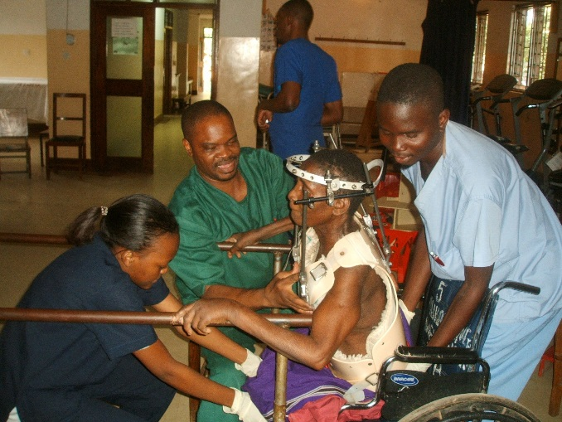By bringing in their vast experiences, IUNV doctors continued to render both bed side and lecture training during the period under review. These trainings included physiotherapy, surgery, anesthesia, medicine and obstetrics and gynecology. Figure 3 shows an IUNV doctor providing physiotherapy training at QECH. Malawi will have its first graduation of 26 physiotherapists in 2014 – well exceeding the 11 targeted. This is a great credit to the IUNV Physiotherapy Team at both QECH and KCH who have been instrumental in the practical training of these graduates.

Figure 3: Physiotherapy Training by an IUNV at QECH

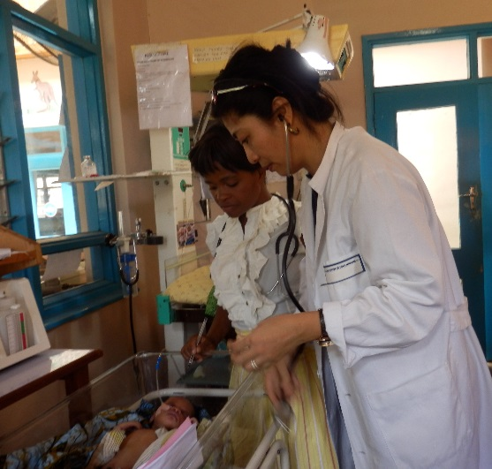In 2006, IUNV doctors introduced a unique cost effective in-service training method for surgical students at Kamuzu Central Hospital through the College of Surgeons East, Central and Southern Africa (COSECSA). This training is conducted in 9 countries – Malawi, Mozambique, Zimbabwe, Uganda, Ethiopia, Kenya, Tanzania, Zambia and Democratic Republic of Congo. Through COSECSA, surgical students have an opportunity to develop both clinical and academic skills without having to leave their posts, while working towards a professional qualification. A total of 6 students at Kamuzu Central Hospital now have membership qualification and 12 are under training. Figure 4 depicts an IUNV surgery on a child at ZCH.

Figure 4: An IUNV Doctor Conducting Pediatric Surgery

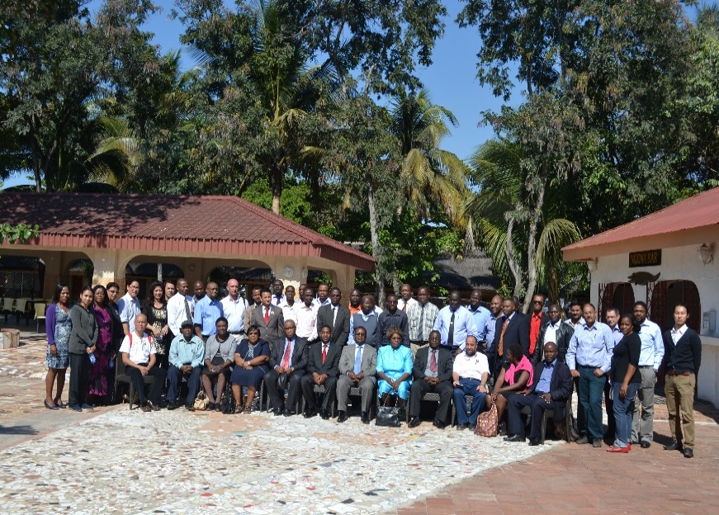From June 19 – 20, 2014, the Ministry of Health, with financial assistance from the CD in Health Project, conducted a *“UNV Doctors Learning Forum”.* (See Figure 5)*.* The purpose of the Forum was to: (a) provide a platform for participants and partners with various backgrounds to exchange information on various aspects of health care delivery ranging from the realities and challenges of health service provision in a resource constrained setting to the innovative approaches that are adopted to ensure efficiency under such settings; (b) share their experiences and provide feedback on their contributions in the health sector to government of Malawi, Ministry of Health, donors, UN Agencies and other key stakeholders in the health sector; (c) provide opportunities to various stakeholders to hear the experiences of IUNV doctors from the field perspective and facilitate exchange of knowledge and expertise in various medical areas and challenges; (d) identify opportunities and strategies to strengthen IUNV doctor project contributions to the achievements of equitable and sustainable health services delivery in the country; (e) opportunity for knowledge management and sharing on the lessons learnt, successes and challenges of the Capacity Development in Health project; and (f) provide a platform to share experiences, knowledge and best practices on the contributions of IUNV doctors in the health sector and develop recommendations for the improvement of the health sector systems for improved service delivery.

Figure 5: Participants at IUNV Doctors Learning Forum

Following the Forum, a number of recommendations were agreed on. Key among them was:

* The continuation of the Capacity in Health Project, as concluded in the “IUNV Doctors Exit/Retention Strategy”, given the shortage of Malawian Specialist doctors and the need to provide specialist medical services for a wide range of conditions for which the Government otherwise has to refer patients abroad for assistance;
* The need to improve operating theatres and theatre space especially in Mzuzu Central Hospital;
* The need to increase uptake of ARVs in the pediatric wards of Malawi’s hospitals;
* That free medical services in Malawian hospitals are not sustainable. Plans by the Ministry of Health to introduce health insurance are underway;
* That the Malawi Council of Medicine should look into attracting junior doctors to work in other central hospitals such as Mzuzu and Zomba;
* Improve internet and library services in the hospitals to allow doctors download recent Journals; and
* The need for the Ministry of Health to encourage its clinical officers to undergo COSESCA program. At the same time, participants recognized the 12 resident trainees at KCH undertaking COSESCA training.

***Output 3****: Three central hospitals (Mzuzu, Kamuzu and Zomba) establish specialized units for physiotherapy, cardiology and oncology to remedy non-communicable disease conditions by 2016.*

* ***Indicator 1:*** *# of patients accessing physiotherapy, cardiology and oncology specialist units per year.* ***Baseline****: Physiotherapy TBD Cardiology TBD and Oncology TBD (2012).* ***Target:*** *Physiotherapy TBD Cardiology TBD and Oncology TBD (2016).*

Key under this Output was the procurement of equipment for the different central hospitals and continuation of Capacity Development Initiatives (CDIs). The Ministry completed a needs assessment on procurement of basic equipment and supplies as a means of strengthening CDIs. Following this, procurement of basic equipment was initiated. This equipment included an autoclave, oxygen concentrators, suction apparatuses, air compressor nebulizers, ventilators, and high frequency electrosurgical units. Teaching equipment and books were also procured for the Physiotherapy Department at KCH. One interesting CDI proposal was the procurement of equipment to assist those that have eye cataracts submitted by Kamuzu Central Hospital expected to benefit 3,000 patients per year.

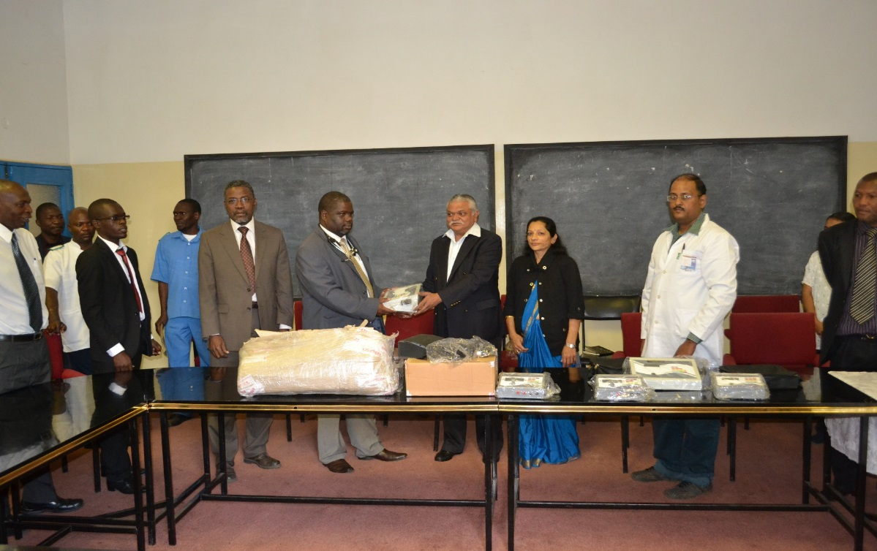The doctors were also involved in soliciting equipment from friends and organizations in their home countries and/or private sector. At KCH, an IUNV doctor negotiated MK4.5 million worth of equipment with a local Asian community businessman for the Physiotherapy Department. (See Figure 6). The equipment is mainly used in chronic as well as acute pain management and includes ultra sound therapy, interferential therapy units, nerve-muscle stimulators, and shoulder wheels. With this equipment, the rehabilitation of patients is now quick and KCH now capacity to efficiently and effectively treat serious injuries including nerve injuries and other non-communicable diseases like stroke.

Figure 6: Handover of Equipment Sourced by an IUNV Doctor

***Output 4:*** *Effective and efficient project management*

* ***Indicator 1****: % of Project Board decisions and recommendations implemented annually.* ***Baseline:*** *75% (2012);* ***Target:*** *85% (2014)*
* ***Indicator 2:*** *% of project results achieved as per the AWP.* ***Baseline:*** *60% (2012);* ***Target:*** *80% (2014)*

This Output was ***partially met*** as all the critical decisions made towards directing the Project were implemented. However, some activities planned in the AWP were not done and/or delayed. A case in point were delays in procurement of equipment

A total of three decision-making meetings were conducted during the year -- two Project Board Meetings and an Extraordinary Project Meeting. During the January Board Meeting, a key decisions was made to put together an “Exit/Retention Strategy for the Project”. Such a Strategy would serve as a tool for resource mobilization as well as inform all stakeholders on the timing of gradual phasing out of the Project. The World Health Organization was tasked to lead the process. An independent consultant was engaged and a Strategy was finalized in June 2024. The Strategy was presented and adopted at the July 2014 Board Meeting.

Despite the Strategy, resource mobilization continued to be a problem. An Extraordinary Meeting was called for in September 2014 where a decision was made not renew contracts of all IUNV doctors but allow them run to their expiry dates. A total of 25 doctors had their contracts expiring on December 31, 2014. Repatriation of these doctor went on as planned with the first doctor leaving in October 2014. An additional 4 doctors whose contracts were ending in 2015, either resigned due to personal reasons and/or funding uncertainties. In 2015, the Project will only have 10 doctors with varying contract expiry dates – the last one being July 2015. A deliberate decision was made to reserve some funds for maintenance of the remaining doctors.

The project also underwent a National Implementation Modality (NIM) Audit with very minor queries. An action plan for the recommendations given was implemented.

**B.2 Progress towards Achieving Outcome and Expected Impact**

The best way to describe the contribution of IUNV doctors is what was captured by the *“IUNV Doctors Exit/Retention Strategy”* consultant during his visits made to the country’s central hospitals and the College of Medicine in Blantyre. Hospital Directors were unanimous in regarding the IUNVs as a valuable addition to their staff. In the words, the Director of Zomba Central Hospital stated that *“If they were to leave, we would cease to be a referral hospital”*. This good opinion extended also to the GPs who, although not qualified as medical specialists, were often performing specialist roles.

IUNVs have two main functions in most central hospitals: direct service provision and teaching. For example, an IUNV physiotherapists in QECH and KCH took over and developed which could otherwise be termed as “moribund” departments. In Neurosurgery Department, in spite of many resource challenges, since 2012, a total of 2,300 patients with head trauma, 763 with brain pathologies and 1,100 with congenital brain anomalies have been treated by an IUNV neurosurgeon with a success rate of 82-85%. Some specialist IUNV doctors take part in general duties, including being on call, but at the same time they were able to deploy their specialist skills to serve previously neglected groups of patients. Specialists also conducted operations during outreach visits. (See Figure 7).

Figure 7: Patients Operated Upon

The IUNV doctors continue enhance knowledge and skills through teaching -- although opportunities for teaching vary with the location. They teach staff of their own departments through morning handovers, ward rounds and in theatre sessions. The departmental staff concerned are junior doctors, clinical officers and nurses. Formal instruction of medical undergraduates mostly takes place in Blantyre, and of interns in Blantyre and Lilongwe. Along with Malawian colleagues and staff of the College of Medicine, IUNV specialists participate in the practical teaching in the clinical setting of undergraduates, interns and residents in specialty training programs. Dentists teach dental therapists who deliver the bulk of medical care in Malawi, while the core function of the HIV Program Supervisors is to mentor the Clinical Officers, Medical Assistants and others providing ART in health centers and clinics.

IUNVs surpass their job descriptions in all kinds of enterprising and constructive ways. Several have mobilized funds, either from friends and family, or from the commercial sector, to buy much needed equipment and supplies for their departments. The dentist at ZCH used his personal connections to obtain $27,000 worth of equipment and supplies. The physiotherapists at KCH sourced K4.5 million from commercial connections to equip the department. These stories could be multiplied.

Some specialists undertake research, for example, the neurosurgeon at KCH is investigating epilepsy, while the pediatric surgeon specialist at QECH undertook research on patient management which led to a considerable reduction in length of stay. At MCH, all the IUNV specialists undertook outreach visits to district hospital. In some cases, they were able to treat patients at the district hospital and in all cases they were able to instruct the district level clinicians on the indications for referral. Due to shortage of doctors, in ZCH and MCH, IUNVs were given the responsibilities to head departments with all the administrative duties that attach to that position.

The majority of IUNVs have shown enthusiasm and dedication above and beyond the call of duty. Where a few have been discouraged by the constraints of operating in a low resource environment, they have been encouraged and sustained by their volunteer colleagues. Of course, it is not credible that in any group of 40 men and women, all reach the same standard of excellence, but although specific enquiry was made on this point, none of the Hospital Directors were dissatisfied with any of those currently in post. The cases of unsatisfactory performance that they cited were all historic. The clear conclusion that can be drawn from this appraisal is that the IUNV scheme is meeting, if not surpassing, legitimate expectations.

**B.3 Gender Mainstreaming**

As regards gender mainstreaming, while there are no statistics by gender on those accessing healthcare services, the Project had seven specialist doctors recruited in the area of obstetrics and gynaecology as well as paediatric. This shows the commitment to deal with maternal issues in hospitals among others. In addition, considering that the majority of population accessing ART services are women, it can also be concluded that the strategies to mainstream gender was successful.

**B.4 Status of Key Partnerships and Inter-Agency/Departmental Collaboration in the Areas of the Outcome**

This project has synergies with a number of other projects with the Country Office. For example, while the HIV/AIDS Project under DGMDG works at policy level, the Capacity Development in Health Project translates such policies into actual healthcare service delivery. The Project also provides real time monitoring information to Development Effectiveness and Accountability Program (DEAP). At the same time, it draws on expertize from DEAP in terms of monitoring and evaluation expertise. The relationship with other projects was more complementary than competitive.

While there was no review of implementing partners, during the design of the Project, efforts were made to clearly define the roles of responsible parties. For example, realizing that UNDP has little expertize in health-related issues, a decision was made to bring in closer collaboration with WHO. As a result, WHO was key in the development of Exit/Retention Strategy for the Project – so too other UN Agencies such as UNAIDS. Efforts were also made to understand volunteer interventions in the same area by other donor and/or development partners such as Japanese Overseas Volunteer Cooperation (JOVC), American PEACE Corps, Clinton Health Initiatives, British Volunteer Service Organization to mention a few.

The Capacity Development in Health Project has had contributions from GFTAM through either the Ministry of Health or NAC. However, in 2014, the Project benefited from funding by the Royal Norwegian Embassy (RNE). This was a *“one-off”* funding following budgetary support suspension by the Embassy due to September 2013 financial mismanagement.

1. **Financial Status and Utilization**

The Capacity Development in Health Project had a 2014annual budget of $2,605,107. Of this, $1,675,978 was cost sharing contribution from the Royal Norwegian Embassy with the remaining $929,129 was from GFTAM through NAC. Total expenditures by end-December 2014 were $2,304,095 leaving a balance of $301,201. *Annex II* shows utilization of funds by output.

1. **Lessons Learned**

A major lesson learned is the need for putting together an exit strategy within the Project design. The Capacity Development in Health Project started in 2004. The recruitment of IUNV doctors was largely driven by the availability of funding than the actual needs. The need for exit strategy only became apparent when resources started drying up. This was somewhat too late to save the Project.

In addition, it was observed during implementation that counterparts provided by the Ministry were somewhat at levels lower than expected. While IUNV doctors committed themselves to transferring skills and knowledge, it was observed that the gap in both qualification and skills undermined achieving the intended results under this output.

## Future Work Plan

Considering that no funding has been identified for the Project, major actions in 2015 will include: (i) repatriation of the remaining 10 IUNV doctors upon expiration of their contracts; (ii) final project evaluation; and (iii) closure of the Project.

**Annexes:**

1. Project Plan for the Period of Review (AWP or Quarterly)
2. Financial Report

1. *NAC contributed $1,059,851 in December 2013 towards the Project. However, only $929,129 was carried forward into 2015.*
2. *Expiry dates for the remaining 10 doctors are spread between January and July, 2015.*
3. The ART Supervisors are deployed in district zonal officers (Northern Zone, Central East Zone, CWZ = Central West Zone, South West Zone and South East Zone) where they provide HIV/AIDS regiment treatments.